**Prom Dress/Suit Sale**

When: March 21, 2020 (date change)

Time: 9:00am-12:00pm

Where: Hazel Park Recreation Center

Cost: No dress or suit over $5.00

*Highschool ID is

required for purchase

*\*\*NEW this year is suits and ties\*\**

All proceeds benefit youth

programming/sports at

Hazel Park Recreation Center.



If you have a gently used dress, suits, ties, dress shoes, or accessories

that you would like to donate please contact

Hazel Park Recreation Center.

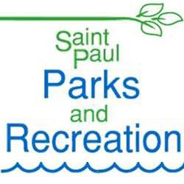

Hazel Park Recreation Center

945 N. Hazel St., Saint Paul, MN 55119

Phone: 651-501-6350