2020 Framingham Cultural Council Members
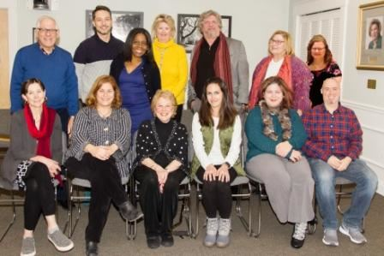
Back Row: Joel Winett (Chair), Everton Vargas da Costa, Leslie White Harvey,
Mary Beth Sheetz, Philip C. Kaplan, Vicki Hammel, Vanessa Pendexter
Front Row: Cindy Walsh, Julie Wiseman, Lois Levick, Marie Perez (Treasurer), Shannon Stevens, Chris Roppola (Vice-Chair/Secretary)

