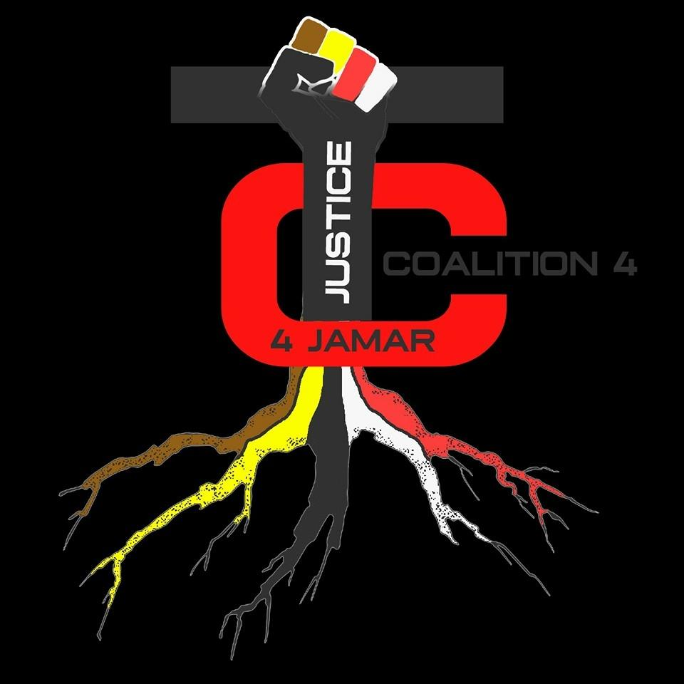Twin  Cities  Coalition  for Justice  for Jamar  Sam Martinez  612.276.2059  Website: tcc4j.net  FaceBook & Insta @TCC4J  justice4jamar@gmail.com | PRESS RELEASE  Trust the city council? Uh, no.  TCC4J response for June 26, 2020 Minneapolis City Council meeting  RE: Community Safety and Violence Prevention charter amendment (2020-00668)  The councilmembers’ proposed charter change to the police would essentially simply rename the Minneapolis police department and would give themselves (the city council and mayor) the power to anoint the head of the newly-named department (the “Department of Community Safety and Violence Prevention”).  TCC4J is against their proposal. For years, we have been calling for community control of the police via CPAC - an all-elected, all-civilian council with power over the police department to hire, fire and prosecute cops.  Here are just a couple of reasons to be against the city council’s proposal.  First, all the power would still be in the hands of the council and mayor's office. Both bodies have long track record of letting the police murder and maim with impunity. They had their chance, many chances over several decades, and they blew it. There is no reason to believe that in a few months, the city council won’t revert back to appeasing the police force and the FOP.  Also, there are no details in the proposal about how things would change, except in name and in letting the city council have a say (instead of just the mayor) in picking the new “director.” Our CPAC proposal spells out in great detail what needs to be done. When CPAC gets onto the ballot or before the council, the people will know what they are voting for.  The city council’s proposal does not spell out any new disciplinary measures or oversight of the police, nor does it spell out what community involvement will look like beyond a vague “consistently engaging the public…” Without discipline and true community engagement (and not token community involvement, either), change will not occur. This proposal is trying to take the easy way out: saying what they think the public wants to hear without doing the hard work of getting rid of violent cops.  Since the righteous uprisings in Minneapolis and around the world after the murder of George Floyd, elected officials have been scrambling like cockroaches after the lights got turned on. Then they retreat to the dark again and do most of their business in secret.  Renaming the police department and giving it a new “mission statement” is not what we need now. We need actual community control of the police.  ###

