Win or lose, Responsible Gambling Council's Know the Score program shows odds in gaming

By Pamela Roth, The Leader-PostMarch 2, 2010

- Story
- Photos ( 1 )

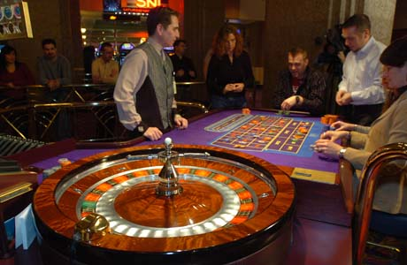

The Responsible Gambling Council (RGC) will be launching its Know the Score (kts2) program on campuses throughout Saskatchewan.

Photograph by: Bryan Schlosser, Leader-Post files
REGINA — Tiffany Kearse knows she will never have a problem with gambling.
The 19-year-old University of Regina student stays away from casinos, even though a couple of her friends like to take their chances at the roulette tables once a week, and often come out empty-handed.
"It's easy to get caught up in the excitement. I think it's scary how fast you can lose money," said Kearse, who has noticed the televised poker championships make gambling seem glamorous to young people.
"I think that causes problems because they think they can get to that level when really it's very rare, just like being a professional athlete."
In order to create more awareness amongst post-secondary students that gambling isn't always glamorous and can lead to problems, the Responsible Gambling Council (RGC) will be launching its Know the Score (kts2) program on campuses throughout Saskatchewan.
The program uses on-campus staff and an interactive website to communicate with students and to test their knowledge about gambling through a five-question quiz.
It looks at the real chances of winning and losing, highlights signs of problem gambling and suggests ways to keep gambling safer.
According to Jon Kelly, CEO for the RGC, the program has been successful in getting the message to young people, who are the most at risk of developing gambling problems.
"They are risk takers in many ways. The 18-to-24 age groups are much more likely to try gambling, get involved in it and have a gambling problem than any other age group," said Kelly, who introduced the program at the U of R on Monday. "We are not trying to persuade people they have a gambling problem, but if somebody does have a problem and they are in that age group, their peers are very influential and likely to be vocal about it."
The kts2 program was developed in 2001 with input from a number of college and universities.
So far the message has been delivered to more than 109 campuses across Canada and parts of the U.S.
Since young people are more vulnerable to the dangers of gambling, Laura Ross, MLA for Regina Qu'Appelle Valley, said it's important to bring more awareness about the issue to the province.
"This is very important to Saskatchewan," said Ross
"The program has proven itself as an effective tool to make students aware of gambling."
More information about the kts 2 program is available at www.kts2.ca.
proth@leaderpost.canwest.com
© Copyright (c) The Regina Leader-Post
*

