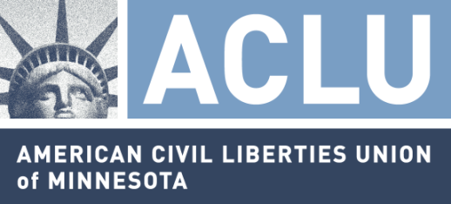
ACLU-MN, Greater Minnesota Racial Justice Project North announces 3rd annual art exhibit, “Art from Within”
Greater Minnesota
Racial Justice
Project—North
P.O. Box 133
Bemidji, MN 56619
T/218-444-2285
F/218-444-7860
gmrjp@aclu-mn.org

FOR IMMEDIATE RELEASE
Thursday, January 19th, 2012

Contact: Cory Cochrane, ACLU-MN, Greater Minnesota Racial Justice Project North, at 218-444-2285
Bemidji

Bemidji—The Greater Minnesota Racial Justice Project North, of the American Civil Liberties Union-Minnesota is pleased to announce the third annual “Art from Within” exhibit. The Art from Within show features artwork that gives a personal and compelling view into the lives of real people whose civil liberties, protected under the Bill of Rights, have been challenged, violated or tested in some way. Past exhibits highlighted the art of individuals impacted by incarceration directly or indirectly. This year’s show will take place at the Bemidji Community Arts Center (BCAC) from March 2nd through March 31st with an opening reception on March 2nd from 4:00—7:00pm.

Now in its third year, Art from Within provides an important venue for American Indians as well as non-Natives who have been impacted by the criminal justice system, to express their lived experiences through the medium of art. This year’s theme focuses on artists’ feelings and understandings about what the Bill of Rights means to them. First Amendment freedom of expression is guaranteed for all who reside in the United States, regardless of their civil status. Art is another way that those whose voices are often suppressed can find an audience.

The call for entries is open to emerging or established artists. American Indians from Minnesotan tribes are strongly encouraged to submit entries. Applications are due by February 1st, 2012. Art from Within is made possible by Region 2 Arts Council, Blandin Foundation, and the Cy and Paula DeCosse Fund. For more information, please visit: http://www.aclu-mn.org/issues/racialjustice/greaterminnesotaracialjust/gmrjpnorth/newsfromupnorth/

The American Civil Liberties Union of Minnesota is a non-profit, non-partisan organization dedicated to defending and expanding individual rights and personal freedom. The ACLU is the nation's foremost guardian of liberty. The ACLU-MN fights to protect civil liberties of Minnesotans through litigation, public education, and lobbying. The Greater Minnesota Racial Justice Project North provides public education regarding racial justice issues through community outreach, court-monitoring, and intake services.

