BALLET & TAP DANCE CLASSES 2021

The 3-4-year-old class is a good class for beginners and students who have taken dance class before. The class is for ballet, tap, and creative movement.
The 5-6-year-old class is also good for beginners and students who have taken dance before. This class is for ballet and tap.
The class that is for 7-10-year old is more of an intermediate and incorporates advanced dance steps. This class is ballet and tap as well as learning some lyrical dance moves.
The 11-15-year old is more advanced. Students will learn difficult tap combination steps as well as ballet, lyrical, and jazz.
3-4 years old
Start date: Monday, February 22
Time: 5:30pm-6:00pm

5-6 years old
Start date: Monday, February 22
Time: 6:15pm-7:00pm

7-10 years old
Start date: Monday, February 22
Time: 7:15pm-8:00pm

11-15 years old
Start date: Thursday, February 25
Time: 6:00pm-7:00pm

St. Paul Parks & Recreation follow the CDC/Covid-19 procedures. There will only be one spectator per child. Spectators must pre-register each week.
Temperatures will be taken, and a mask must always be worn.
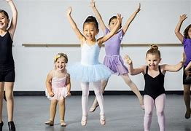
Battle Creek Recreation Center
75 Winthrop Street So.
St. Paul, MN 55119
651.501.6347

