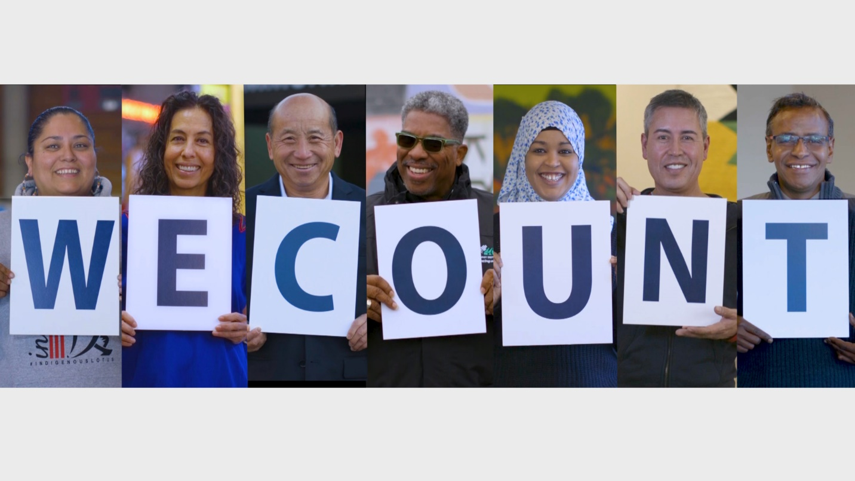

As of today, September 8th, there are only 22 days left to complete the 2020 census. Participating in the census is critical to the future of our communities, our economy and our safety. Not only does the census count determine our political representation, but data that is obtained by the census also helps to allocate over $800 billion in federal resources that our communities rely on. Programmatic support for services like SNAP, CHIP, Head Start and housing and food assistance all rely on population statistics derived from the census. In addition to political representation and resources that help support community, the census also effects our economy and public safety. When businesses are determining where to place new offices or factories, they rely on census data. When real estate developers are deciding where to build new homes, apartment complexes or affordable housing, they too rely on the data from the census. City planners and public safety and health officials also rely on census data to ensure their emergency preparedness during times of crises. During the COVID-19 pandemic, census data was used to determine how many ventilators were needed in Minnesota. Our transportation systems, our roads and even our parks are dependent upon accurate census data.
In Minneapolis, we currently have several neighborhoods that are beneath a 50% census response threshold, which if not counted could have long lasting and devasting impacts on our communities. Without an accurate count, our city will go the next decade without the proper resources that are needed to meet our needs. Historically, children under 5 are the larger undercounted group in the nation and are too often left off of the census form.
If you haven’t yet completed the census:
Be sure to complete the census for you, your entire family and for your community. You can get counted today by visiting my2020census.gov or calling 1-844-330-2020 where assistance is provided in several languages. Make sure that you include every person that is living in your household.
Additional assistance can be found by census staff out in community. The City of Minneapolis will have a Census presence at the following events:
- Four Sisters Farmers market on Thursdays
- Powderhorn Park food distribution on Fridays
- Sanctuary Covenant food distribution on Fridays
- Reimagine 38th (on 38th and Chicago) on Saturdays
How to help if you have completed the census:
- Help us spread the word!
  - Right now, Minneapolis has several neighborhoods that have less than 50% completion for the census. If you know someone who lives in one of the following neighborhoods, encourage them to complete the census:
    - Jordan
    - Hawthorne
    - Prospect Park
    - Como
    - U of M
    - Ventura
    - Cedar Riverside
    - Whittier
    - East Phillips
    - Elliot Park

- Post about the census on social media!
  - Include the link My2020census.gov and encourage your networks to complete the census so that our communities are counted

We matter, we add value and we count!
