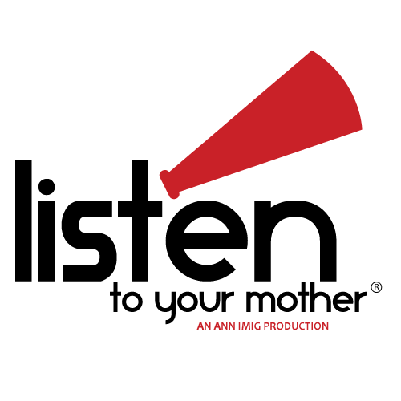
Attention WRITERS! CALL FOR SUBMISSIONS!

Listen to Your Mother is a live stage production of local writers reading their
stories about motherhood. The Twin Cities show is part of an exciting nationwide series of shows in 24 cities, including New York, San Francisco and Chicago. All shows are held on or around Mother's Day.

The Twin Cities LTYM directors are seeking a diverse collection of local writers to read their own words about motherhood. People of all ages, backgrounds and experience levels are invited to submit their work. Remember, everyone has a mother story, whether you are a mother or not.

Send your humorous, poignant or soulful words about the good, the bad and
the ridiculous of motherhood to ltymtwincities@gmail.com. Deadline is 2/15/13.

More details at www.listentoyourmothershow.com/twincities

Then mark your calendar for our evening show on Thursday, May 9, 2013,
at the beautiful Riverview Theater in Minneapolis!

Vikki Reich, Galit Breen, Tracy Morrison and Heather King, Directors/Producers, LTYM Twin Cities

**Note: We use a 2-part selection process. The first step is submitting your essay via
email. The second step is an audition. Deadline for submissions is Feb 15, 2013.

